**Association of Mastitis**

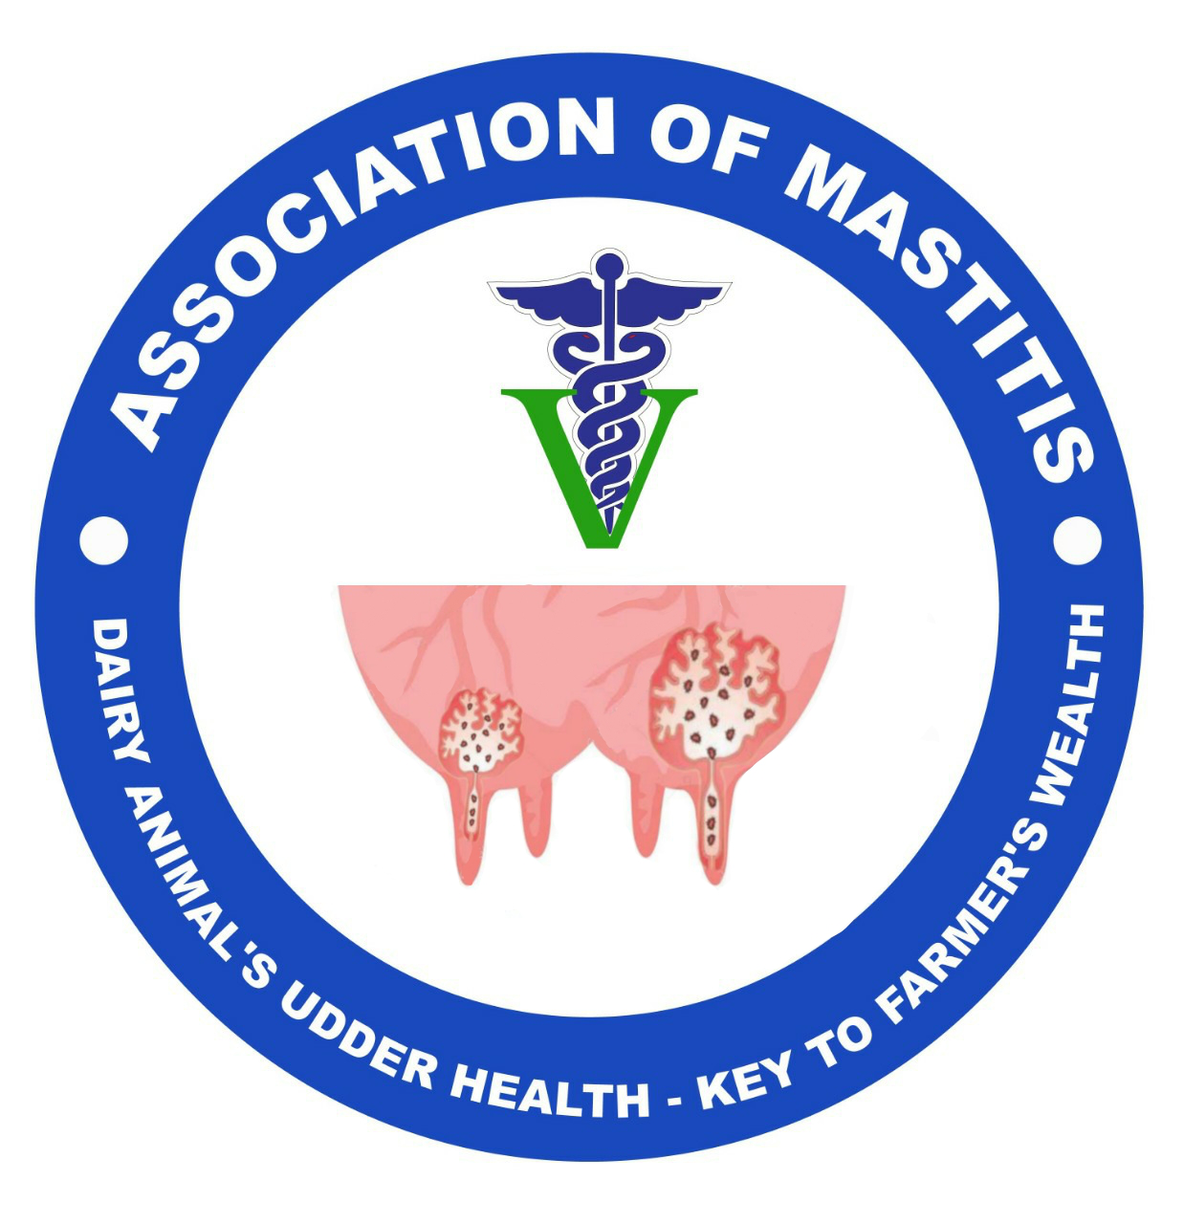

House No. 24/A, Shatabdipuram, Phase-I, Gird,Gwalior, M.P., India

**Website:** http://associationofmastitis.com

**Email: associationofmastitis@gmail.com**

(Registration No.02/42/01/23138/19)

Passport size colored photo

**MEMBERSHIP FORM**

**To**

**General Secretary**

Association of Mastitis

I wish to be a registered member of “**Association of Mastitis**”. I am willing to act as a resource person for the various programmes conducted by Association of Mastitis and also promote the objectives of the association for the benefits of dairy farmers, scientific community and policy makers for the development of Association in general.

|  |  |
| --- | --- |
| **Name** |  |
| **Father’s name** |  |
| **Employment status** | Government Employee/ Private sector employee/ Self Employed/ Student: |
| **Designation** |  |
| **Membership Category** | Life Member/Annual Member/Corporate Member/Institutional Member: |
| **Sex** |  |
| **Date of Birth** |  |
| **Name of institution** |  |
| **Correspondence Address with Pin code:** |  |
| **Official Address with Pin code** |  |
| **Email Address** |  |
| **Phone Number** |  |
| **Educational Qualification** | B.V.Sc. & AH/ DVM/M.V.Sc./Ph.D.:  Any other: |
| **Contributions, if any in the field of mastitis/ udder health, clean milk production, milk products technology etc.** |  |
| **MEMBERSHIP FEE PAYMENT DETAILS** | |
| Draft / Cheque / Wire Transfer / NEFT / RTGS / PayPal / Net Banking / SWIFT No  (Transaction ID) | (Attach payment receipt) |
| Dated |  |
| Banker’s Name |  |
| Contribution Amount  Rs / Mention Currency) |  |
| Reference, if any |  |

I read carefully all terms and conditions of the membership of Association of Mastitis and abide by its rules and regulation, more fully stated here above.

**(Name and Signature of applicant)**

**Place: Date:**

**FOR OFFICE USE ONLY**

Application form No. : Receipt No.: Date:

**Receipt**

This to confirm a duly filled life membership application form along with the D.D., Cheque/ NEFT (No……………………………; Bank Name:……………………….. of Rs. -----has been submitted by Dr. ----------------------------------, Father’s name Mr. --------------------------------------------------------------------

Date.

Place. (Signature of Receiving Authority) Name:-------------------------------------------------------------- Designation : ------------------------------------------------------

FOR OFFICE USE ONLY

Decision of the managing Committee:

APPROVED AS LIFE MEMBER / ANNUAL MEMBER/PATRON / CORPORATE / HONORARY MEMBER

NOT APPROVED.

Membership No.:

|  |  |
| --- | --- |
| Date ………….. | Signature __________________________                                  General Secretary |

**General Guideline**

**Membership Fee details:**

|  |  |  |
| --- | --- | --- |
| **Type** | **Life Time** | **Annual** |
| Corporate Membership | INR 30000/- | INR 20000/- |
| Institutional Membership | INR 20000/- | INR 10000/- |
| International Members | USD 100 | USD 75 |

**Bank details:**

**Bank Name:** HDFC Bank

**Branch:** Ranbir Singh Pora

**Name of Account Holder:** “Association of Mastitis”

**Account No.:** 50200050366813

**Account Type:** TASC Current Account

**IFSC code:** HDFC0002229

**Branch code:** 002229

**MICR:** 180240008

**Swift Code:** HDFCINBB

1. *Eligibility*: All Veterinarians, scientists and post-graduate students of all disciplines including Animal/Veterinary science working on different aspects of mastitis diagnosis, treatment, udder anatomy, physiology, pharmacology, pathology,milk and milk products etc. and field Veterinarians are eligible for the membership.

2. A private or a public limited company, limited liability partnership or a partnership firm collectively referred to as “Corporate Member”) is eligible to become a member of the society.

3. The institutional member seeking to be a member, shall along with its application, submit its constituent document such as memorandum of association, articles of association, trust deed, rules and regulations.

4. Members are eligible for benefits such as reduction in membership fee for events, conferences, workshops sponsored and/or conducted by **Association of Mastitis**.

Please send the filled form either by Post or Via Email and cheque/DD in favor of “**Association of Mastitis “**

***Correspondence Address***: Prof. (Dr.) Neelesh Sharma, Division of Veterinary Medicine, F.V.Sc. & A.H., SKUAST-J, R.S. Pura-181 102, Jammu, UT of J&K, India.

**Note: Please send scan copy of the application form at: associationofmastitis@gmail.com**

**Association of Mastitis**

***Registered Office***: House No. 24/A, Shatabdipuram, Phase-I, Gird, Gwalior, M.P., India